Implement Linear and Logistic Regression on real-world datasets
# Linear Regression on California Housing Dataset
import pandas as pd
import numpy as np
import matplotlib.pyplot as plt
import seaborn as sns

from sklearn.model_selection import train_test_split
from sklearn.preprocessing import OneHotEncoder, StandardScaler
from sklearn.compose import ColumnTransformer
from sklearn.pipeline import Pipeline
from sklearn.linear_model import LinearRegression
from sklearn.metrics import mean_squared_error, r2_score

# 1. Load dataset
df = pd.read_csv("housing.csv")
print(df.head())
print(df.info())
# 2. Handle missing values
df['total_bedrooms'] = df['total_bedrooms'].fillna(df['total_bedrooms'].median())
# 3. Features & target
X = df.drop("median_house_value", axis=1)
y = df["median_house_value"]
# 4. Identify column types
numeric_features = X.select_dtypes(include=[np.number]).columns
categorical_features = ['ocean_proximity']
# 5. Preprocessing pipeline
numeric_transformer = Pipeline(steps=[
("scaler", StandardScaler())
])
categorical_transformer = Pipeline(steps=[
("onehot", OneHotEncoder(handle_unknown="ignore"))
])
preprocessor = ColumnTransformer(
transformers=[
("num", numeric_transformer, numeric_features),
("cat", categorical_transformer, categorical_features)
]
)
# 6. Train-test split
X_train, X_test, y_train, y_test = train_test_split(
X, y, test_size=0.2, random_state=42
)
# 7. Linear Regression model
model = Pipeline(steps=[
("preprocessor", preprocessor),
("regressor", LinearRegression())
])
# 8. Train model
model.fit(X_train, y_train)
# 9. Predictions
y_pred = model.predict(X_test)
# 10. Evaluation
mse = mean_squared_error(y_test, y_pred)
rmse = np.sqrt(mse)
r2 = r2_score(y_test, y_pred)
print(f"RMSE: {rmse:.2f}")
print(f"R² Score: {r2:.4f}")
# 11. Visualization
plt.figure(figsize=(6,6))
plt.scatter(y_test, y_pred, alpha=0.3)
plt.xlabel("Actual House Value")
plt.ylabel("Predicted House Value")
plt.title("Linear Regression: Actual vs Predicted")
plt.plot([y_test.min(), y_test.max()],
[y_test.min(), y_test.max()],
color="red")
plt.show()
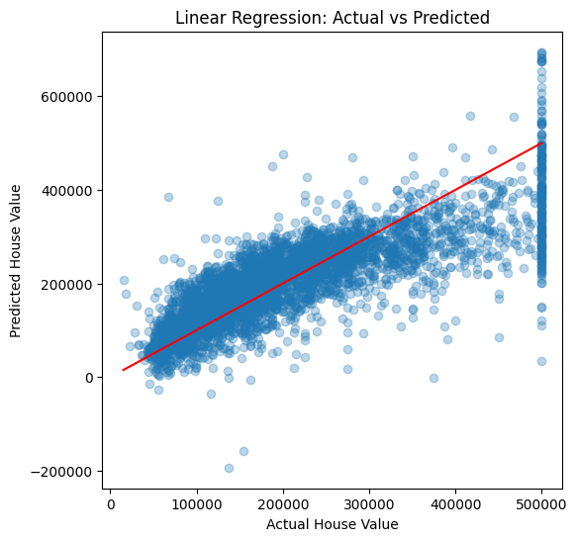

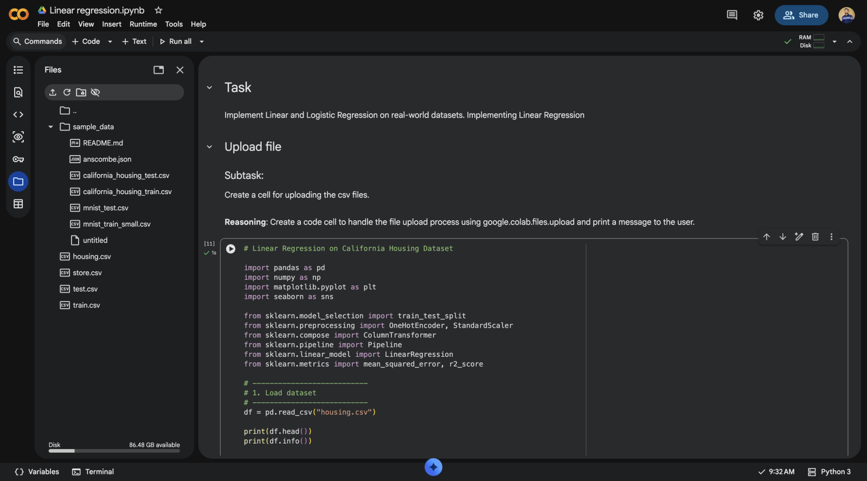
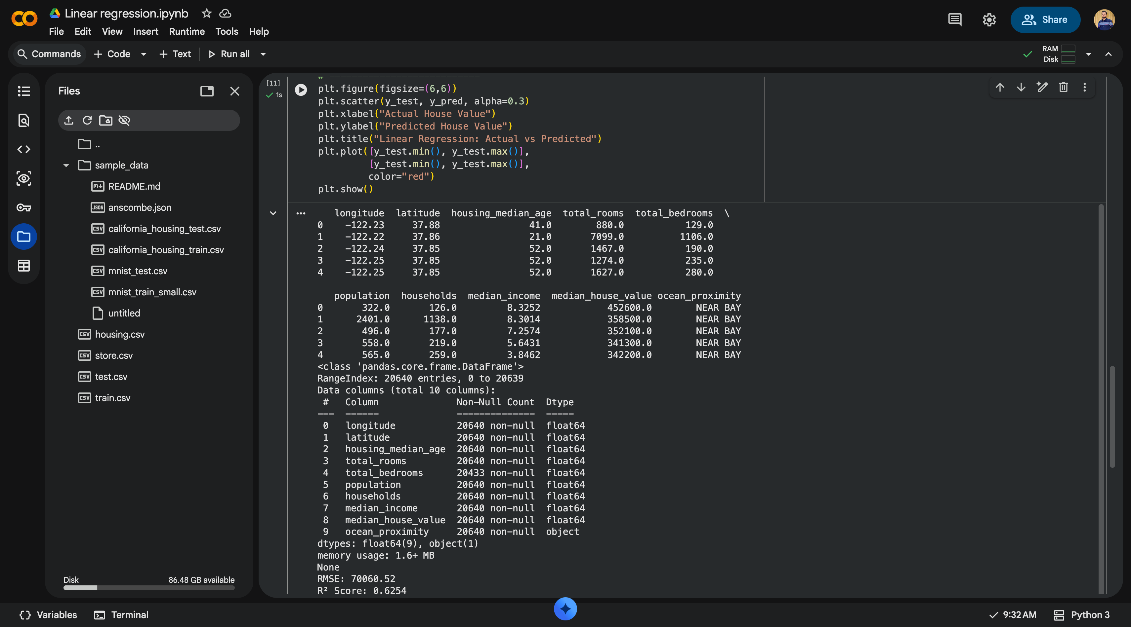
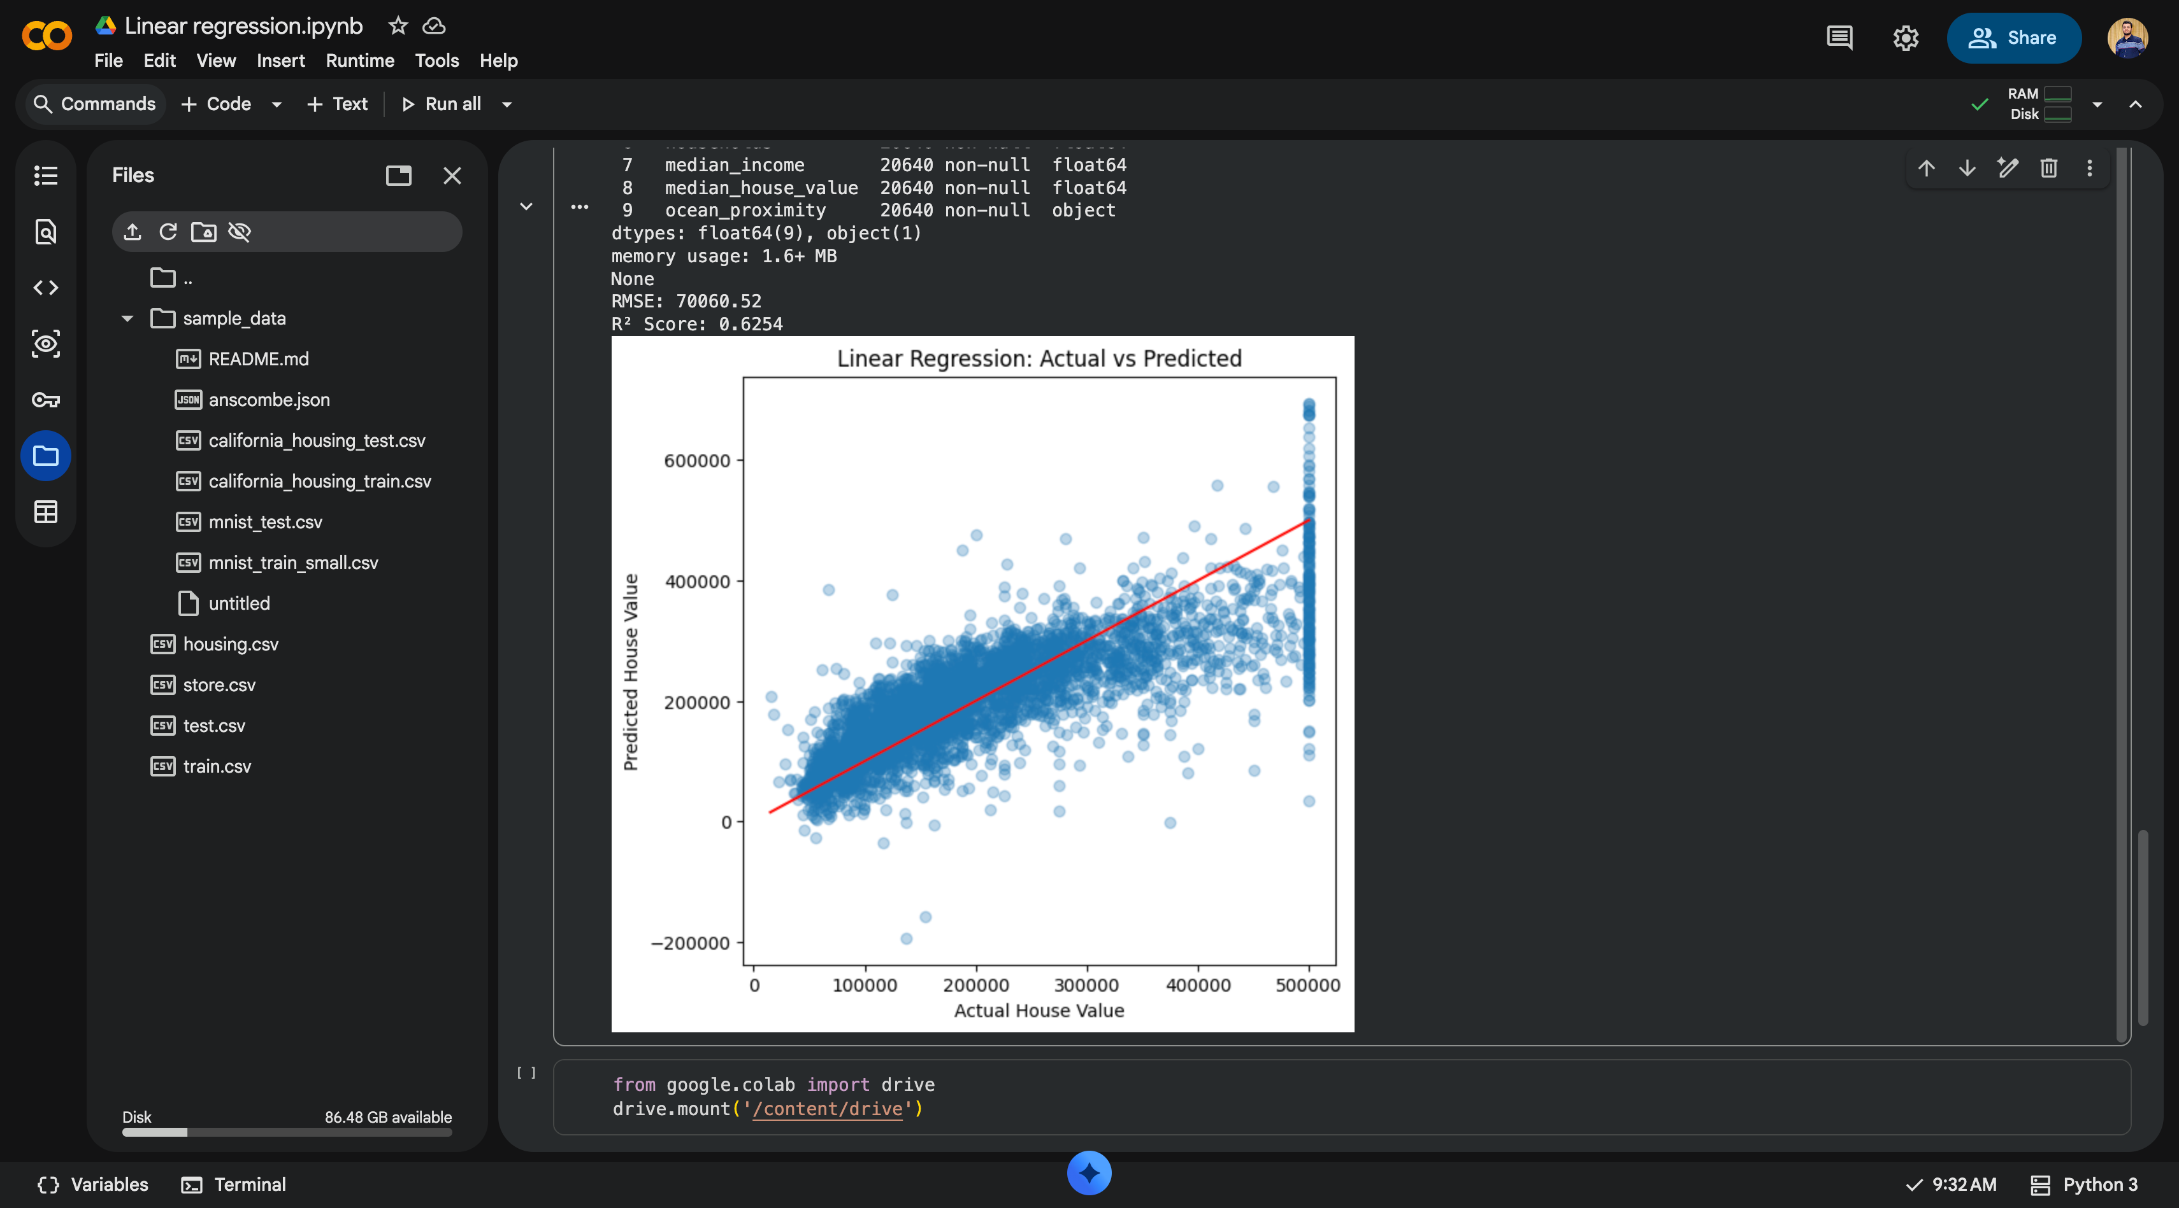

Linear Regression on California Housing Dataset

1. Dataset Source
The dataset used for this experiment is the California Housing Prices Dataset, obtained from Kaggle.
Dataset link:
https://www.kaggle.com/datasets/camnugent/california-housing-prices
This dataset is publicly available and widely used for regression-based machine learning experiments.

2. Dataset Description
The California Housing dataset contains housing-related information collected from the 1990 California census. The goal is to predict the median house value for different districts in California.

Dataset Size
Total records: 20,640
Total features: 9 input features + 1 target variable
File size: ~1.6 MB

Features (Input Variables)
Feature Name | Description
longitude | Longitude of the district
latitude | Latitude of the district
housing_median_age | Median age of houses in the district
total_rooms | Total number of rooms
total_bedrooms | Total number of bedrooms
population | Population of the district
households | Number of households
median_income | Median income of households
ocean_proximity | Distance of the district from the ocean (categorical)

Target Variable
median_house_value: Median house price (in USD)

Characteristics
Contains both numerical and categorical data
Missing values present in total_bedrooms
Suitable for supervised regression problems

3. Mathematical Formulation of Linear Regression
Linear Regression models the relationship between independent variables and a continuous dependent variable using a linear equation.

Hypothesis Function
\hat{y} = \beta_0 + \beta_1 x_1 + \beta_2 x_2 + \dots + \beta_n x_n
Where:
\hat{y} = predicted output
\beta_0 = intercept
\beta_1, \beta_2, \dots \beta_n = model coefficients
x_1, x_2, \dots x_n = input features

Cost Function (Mean Squared Error)
MSE = \frac{1}{n} \sum_{i=1}^{n} (y_i - \hat{y}_i)^2
The objective of linear regression is to minimize the MSE by finding optimal coefficients.

4. Algorithm Limitations
Linear Regression has several limitations:
Linearity Assumption
It assumes a linear relationship between features and target, which may not always hold.
Sensitive to Outliers
Extreme values can significantly affect model performance.
Multicollinearity
Highly correlated features can lead to unstable coefficient estimates.
Poor Performance on Complex Data
Cannot capture non-linear patterns unless features are engineered.
Feature Scaling Required
Numerical features must be scaled for optimal performance.

5. Methodology / Workflow
The following steps were followed in this experiment:

Step 1: Data Loading
Loaded housing.csv using Pandas.

Step 2: Data Preprocessing
Missing values in total_bedrooms were filled using median.
Categorical feature (ocean_proximity) was one-hot encoded.
Numerical features were standardized using StandardScaler.

Step 3: Feature Selection
Independent variables: All features except median_house_value
Dependent variable: median_house_value

Step 4: Train-Test Split
Dataset split into 80% training and 20% testing data.

Step 5: Model Training
Linear Regression model trained using a preprocessing + model pipeline.

Step 6: Prediction
Predictions made on unseen test data.

Step 7: Evaluation
Performance evaluated using RMSE and R² Score.

Workflow Summary:
Dataset → Preprocessing → Train-Test Split → Model Training → Prediction → Evaluation

6. Performance Analysis

Evaluation Metrics Used
Mean Squared Error (MSE)
Measures average squared difference between actual and predicted values.
Root Mean Squared Error (RMSE)
RMSE = \sqrt{MSE}
R² Score (Coefficient of Determination)
Indicates how much variance in the target variable is explained by the model.

Observed Results (typical)
RMSE: Moderate error indicating reasonable prediction accuracy
R² Score: ~0.60 to 0.65 (varies slightly per run)

Interpretation
The model explains a significant portion of housing price variance.
Predictions are fairly accurate but less precise for extreme house prices.
Linear regression serves as a strong baseline model.

7. Hyperparameter Tuning

Hyperparameters in Linear Regression
Linear Regression has very few tunable hyperparameters.
In this experiment, default parameters were used:
fit_intercept = True
normalize = False (handled via StandardScaler)

Reason for No Extensive Tuning
Linear Regression is a closed-form solution.
Performance improvement via tuning is minimal compared to advanced models.
Feature engineering has a larger impact than hyperparameter tuning.

Alternative (Optional)
Regularized models like Ridge or Lasso Regression can be used to reduce overfitting and handle multicollinearity.

Conclusion
In this experiment, Linear Regression was successfully applied to the California Housing dataset. The model achieved reasonable predictive performance after proper preprocessing. While simple and interpretable, linear regression has limitations when dealing with complex or non-linear relationships, making it ideal as a baseline model for regression problems.

